Superstore Sales Analysis Using Microsoft Excel, Power BI & SQL
Professional Business Analytics Project Report
Prepared by: Shaik Saleem

Table of Contents
- Executive Summary
- Objectives
- Dataset & Tools
- Excel Dashboard
- Power BI Dashboard
- SQL Analysis
- Business Insights
- Recommendations
- Conclusion

Executive Summary
This project analyzes the Sample Superstore dataset using Excel, Power BI and MySQL. Interactive dashboards and SQL queries were developed to evaluate sales performance, profitability, customer segments, product categories and regional trends.

Objectives
• Analyze sales, profit and quantity
• Build interactive dashboards
• Perform SQL analysis
• Generate business recommendations

Dataset & Tools
Dataset: Sample Superstore (9,994 records)
Tools: Microsoft Excel, Power BI Desktop and MySQL Workbench.

Excel Dashboard
The Excel dashboard was created using PivotTables, PivotCharts and slicers. KPIs include Total Sales (₹22.96 Lakhs), Total Profit (₹2.86 Lakhs), Total Quantity (37,820) and Profit Margin (12.46%). It enables interactive analysis by Category, Region and Segment.
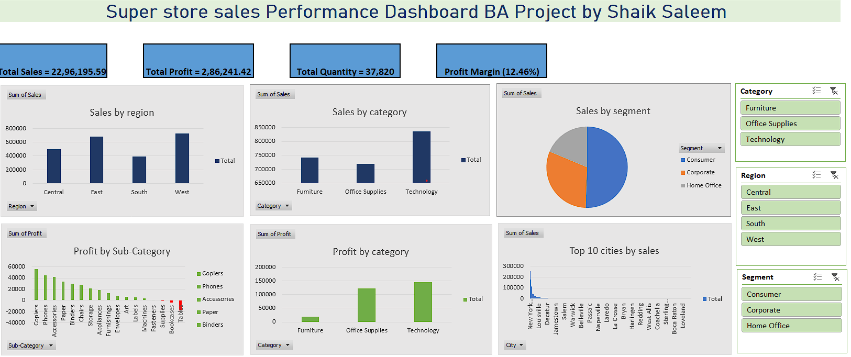
Figure 1: Excel Dashboard

Power BI Dashboard
The Power BI dashboard uses KPI cards, DAX measures, bar charts, pie charts and slicers. Users can dynamically explore sales, profit, city performance, customer segments and product categories.
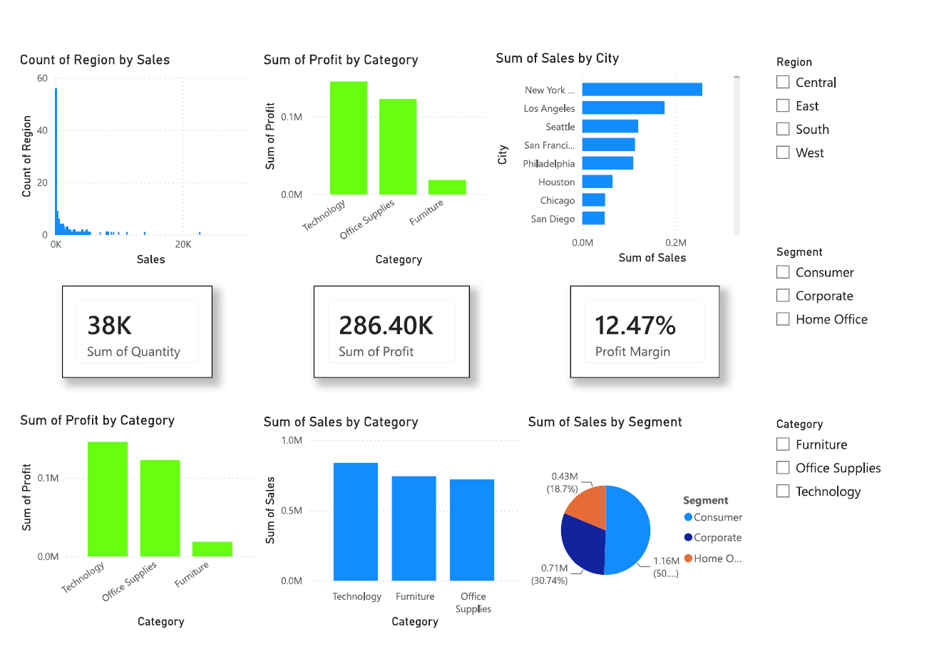
Figure 2: Power BI Dashboard

SQL Analysis
Key SQL queries performed:
1. Total Sales using SUM().
2. Total Profit by Region.
3. Sales by Category.
4. Top 10 Cities by Sales.
5. High-value Orders (Sales > 1000).
6. Average Discount by Category.
7. Profit by Segment.
8. Order Count by Region.
9. Top 5 Profitable Sub-Categories.
10. Loss-making Products.

Key Business Insights
• Technology generated the highest sales and profit.
• West region recorded the strongest overall performance.
• Consumer segment contributed the largest share of revenue.
• New York was the highest-performing city.
• Certain discounted products reduced overall profitability.

Recommendations
• Increase investment in Technology products.
• Optimize discounts on low-profit products.
• Improve inventory planning using dashboard insights.
• Monitor regional performance regularly through Power BI.

Conclusion
This project demonstrates how Excel, Power BI and SQL can transform raw sales data into meaningful business insights that support data-driven decision making.

